### Predictive Modeling Using Historical Sales Data To Forecast Future Product Demands



A

Project Report

Submitted in partial fulfillment of the requirement for the award of degree of

#### Bachelor of Technology

In

#### Information Technology

Submitted to

#### RAJIV GANDHI PROUDYOGIKI VISHWAVIDYALAYA, BHOPAL (M.P.)

**Guided By Submitted By**

Prof. Mahendra Verma Amay Saxena (0827IT221014) Akshat Soni (0827IT221011) Atharv Sharma (0827IT233D02)

Khushi Agrawal (0827IT221076)

#### DEPARTMENT OF INFORMATION TECHNOLOGY, ACROPOLIS INSTITUTE OF TECHNOLOGY & RESEARCH, INDORE (M.P.) 453771

**2024-2025**

Acropolis Institute of Technology & Research

# Department of Information Technology



**Certificate**

The project work entitled **Predictive Modeling Using Historical Sales Data To Forecast Future Product Demands** submitted by Amay Saxena (0827IT221014) Akshat Soni (0827IT221011) Atharv Sharma (0827IT233D02) Khushi Agrawal (0827IT221076) is approved as partial fulfillment for the award of the degree of Bachelor of Technology in Information Technology by Rajiv Gandhi Proudyogiki Vishwavidyalaya, Bhopal (M.P.).

#### Internal Examiner External Examiner

Name:………………. Name: ……………..

Date: …./…/……….. Date: …./…/………..

# Table of Content

**Declaration**

**Project Approval Form Acknowledgement**

**Abstract**

**List of Figures List of Tables Abbreviations**

**Chapter 1: Introduction**

* 1. Rationale
  2. Existing System
  3. Problem Formulation
  4. Proposed System
  5. Objectives
  6. Contribution of the Project
     1. Market Potential
     2. Innovativeness
     3. Usefulness
  7. Report Organization

#### Chapter 2: Requirement Engineering

* 1. Feasibility Study (Technical, Economical, Operational)
  2. Requirement Collection
     1. Discussion
     2. Requirement Analysis
  3. Requirements
     1. Functional Requirements
        1. Statement of Functionality
     2. Nonfunctional Requirements
        1. Statement of Functionality
  4. Hardware & Software Requirements
     1. Hardware Requirement (Developer & End User)
     2. Software Requirement (Developer & End User)
  5. Use-case Diagrams
     1. Use-case Descriptions

#### Chapter 3: Analysis & Conceptual Design & Technical Architecture

* 1. Technical Architecture
  2. Sequence Diagrams
  3. Class Diagrams
  4. DFD
  5. User Interface Design
  6. Data Design
     1. Schema Definitions
     2. E-R Diagram

#### Chapter 4: Implementation & Testing

* 1. Methodology
     1. Proposed Algorithm
  2. Implementation Approach
     1. Introduction to Languages, IDEs Tools and Technologies
  3. Testing Approaches
     1. Unit Testing
        1. Test Cases
     2. Integration Testing

b. Test Cases

#### Chapter 5: Results & Discussion

* 1. User Interface Representation
     1. Brief Description of Various Modules
  2. Snapshot of System with Brief Description
  3. Database Description

5.3.1Snapshot of Database Tables with Brief Description

* 1. Final Findings

#### Conclusion & Future Scope

* 1. Conclusion
  2. Future Scope

#### REFERENCES

**Appendix A:** Project Synopsis **Appendix B:** Guide Interaction Report **Appendix C:** User Manual

**Appendix D:** Git/GitHub Commits/Version History

# Declaration

I hereby declared that the work, which is being presented in the project entitled **Predictive Modeling Using Historical Sales Data To Forecast Future Product Demands** partial fulfillment of the requirement for the award of the degree of **Bachelor of Technology**, submitted in the department of Information Technology at **Acropolis Institute of Technology & Research, Indore** is an authentic record of my own work carried under the supervision of “**Prof. Mahendra Verma** ”. I have not submitted the matter embodied in this report for the award of any other degree.

Amay Saxena (0827IT221014) Akshat Soni (0827IT221011) Atharv Sharma (0827IT233D02)

Khushi Agrawal (0827IT221076)

#### Prof. Mahendra Verma

Supervisor

# Project Approval Form

I hereby recommend that the project **Predictive Modeling Using Historical Sales Data To Forecast Future Product Demands** prepared under my supervision by Amay Saxena (0827IT221014) Akshat Soni (0827IT221011) Atharv Sharma (0827IT233D02) Khushi Agrawal (0827IT221076) be accepted in partial fulfillment of the requirement for the degree of Bachelor of Technology in Information Technology

Prof. Mahendra Verma

#### Supervisor

Recommendation concurred in 2024-2025

Prof. Deepak Singh Chouhan

#### Project Incharge

Prof. Mahendra Verma

**Project Coordinator**

# Acknowledgement

With boundless love and appreciation, we would like to extend our heartfelt gratitude and appreciation to the people who helped us/me to bring this work to reality. We would like to have some space of acknowledgment for them.

Foremost, our would like to express our sincere gratitude to our/my supervisor, **Prof. Mahendra Verma** whose expertise, consistent guidance, ample time spent and consistent advice that helped us/me to bring this study into success.

To the project in-charge **Prof. Deepak Singh Chouhan** and project coordinator **Prof. Mahendra Verma** for their constructive comments, suggestions, and critiquing even in hardship.

To the honorable **Prof. (Dr.) Prashant Lakkadwala**, Head, Department of Information Technology for his favorable responses regarding the study and providing necessary facilities.

To the honorable **Dr. S.C. Sharma**, Director, AITR, Indore for his unending support, advice and effort to make it possible.

Finally, we would like to pay our thanks to faculty members and staff of the Department of Computer Science & Engineering for their timely help and support.

We also like to pay thanks to our **parents** for their eternal love, support and prayers without them it is not possible.

Amay Saxena (0827IT221014) Akshat Soni (0827IT221011) Atharv Sharma (0827IT233D02)

Khushi Agrawal (0827IT221076)

## ABSTRACT

In today's dynamic and competitive business landscape, effective inventory management is critical to ensuring operational efficiency and customer satisfaction. This project presents the development of a Smart Inventory Management System that utilizes predictive modeling techniques on historical sales data to forecast future product demands. The primary motivation behind this work stems from the common challenges businesses face, including inaccurate demand forecasting, stockouts, overstocking, and rising operational costs—issues that stem from poor data utilization and outdated inventory systems.

To address these challenges, the proposed system integrates data analytics and machine learning to analyze past sales trends and generate accurate demand forecasts. We employed a combination of time series analysis and supervised machine learning algorithms to model demand behavior. Real- time inventory tracking was incorporated to provide up-to-date visibility on stock levels, while a user-friendly front-end interface was designed using modern web technologies (e.g., React/Angular). The back-end logic, powered by Python (Flask/Django) or Node.js, handled data processing and communication with a database (MySQL/MongoDB) that stores inventory and sales data. Cloud hosting solutions like AWS or Heroku were considered for scalable deployment.

The results showed a marked improvement in forecasting accuracy compared to traditional manual methods. By leveraging data-driven insights, the system effectively minimized instances of stockouts and overstocking. Additionally, the system's support for multi-location inventory management and real-time analytics provided businesses with actionable insights to make informed supply chain decisions.

The significance of these findings lies in their real-world applicability. This system empowers businesses—particularly in retail, e-commerce, and manufacturing—to streamline their inventory processes, reduce operational costs, and enhance customer satisfaction through timely product availability. Moreover, integrating predictive modeling into inventory management lays the foundation for intelligent, automated supply chain systems that adapt quickly to market changes. This project demonstrates how historical data, when properly harnessed, can drive efficiency and innovation in inventory planning.

### List of Figure

* Figure 1: Use-Case Diagram
* Figure 2: Sequence Diagram
* Figure 3: Class Diagram
* Figure 4: Data Flow Diagram (DFD)
* Figure 5: Technical Architecture Diagram
* Figure 6: User Interface Screenshot
* Figure 7: Entity-Relationship (E-R) Diagram

### List of Tables

* Table 4.3.1.a: Unit Testing Test Cases
* Table 4.3.2.b: Integration Testing Test Cases

### Abbreviations

* SIMS: Smart Inventory Management System
* AI: Artificial Intelligence
* ML: Machine Learning
* ARIMA: AutoRegressive Integrated Moving Average
* LSTM: Long Short-Term Memory
* API: Application Programming Interface
* UI: User Interface
* UX: User Experience
* IDE: Integrated Development Environment
* CSV: Comma-Separated Values
* ERP: Enterprise Resource Planning
* POS: Point of Sale
* DB: Database
* IoT: Internet of Things
* AWS: Amazon Web Services
* RBAC: Role-Based Access Control
* CRUD: Create, Read, Update, Delete

## CHAPTER 1: INTRODUCTION

* 1. **Rationale**

In today’s fast-paced and competitive business environment, efficient **inventory management** is crucial to business success. Poor inventory management can lead to significant operational inefficiencies, increased costs, and reduced customer satisfaction. This section outlines the rationale behind the development of a **Smart Inventory Management System** (SIMS) using predictive modeling.

#### Increased Complexity of Modern Business Operations:

* + As businesses grow and expand, particularly in sectors like retail, e-commerce, and manufacturing, managing inventory becomes more complex.
  + Companies often deal with multiple product categories, locations, and supply chains, requiring advanced tools to manage them efficiently.

#### Common Problems in Traditional Inventory Management Systems:

* + **Stockouts:**

Occur when businesses run out of stock before a replenishment order can be made or delivered. Results in lost sales opportunities, customer dissatisfaction, and long lead times to restock.

#### Overstocking:

Happens when businesses order or maintain too much stock, leading to increased storage costs, spoilage (for perishable goods), and unused capital. Ties up financial resources that could be better utilized elsewhere in the business.

#### Manual Systems and Basic Algorithms Are Inadequate:

* + Many businesses continue to use **manual stock tracking** methods or **basic spreadsheet systems**, which are prone to human error and lack the ability to analyze historical data effectively.
  + These systems fail to provide accurate demand forecasts, leading to inefficiencies in stock management.

#### Lack of Data-Driven Decision Making:

* + Businesses often accumulate vast amounts of **historical sales data** and **customer trends** but fail to leverage it effectively.
  + Relying on instinct or simple algorithms for decision-making leads to inefficient use of inventory and resources.

#### Challenges of Scaling Operations:

* + As companies scale, they face increasing challenges in managing **multi-location warehouses**, coordinating with suppliers, and predicting fluctuating consumer demand.
  + Traditional systems don’t provide **real-time insights** into inventory levels, making it difficult to optimize operations and respond to demand changes swiftly.

#### The Role of Predictive Modeling:

* + **Predictive modeling** uses **historical data**, **seasonal trends**, and advanced **machine learning algorithms** to forecast demand more accurately.
  + By forecasting demand in advance, businesses can optimize inventory levels, reduce operational costs, and enhance customer satisfaction by ensuring products are available when needed.

#### Key Benefits of a Smart Inventory Management System (SIMS):

* + The proposed system will automate the process of demand forecasting and inventory tracking, minimizing human error and manual intervention.
  + **Real-time data analytics** will provide up-to-date visibility into stock levels, improving decision-making and responsiveness.
  + **Data-driven insights** will allow businesses to predict demand patterns and make informed decisions that improve inventory optimization.
  1. **Existing System**

Several inventory management systems are currently in use, each with varying levels of efficiency, automation, and forecasting capability. While some provide basic functionality, others attempt to introduce intelligence through automation and machine learning. However, all existing systems have limitations that restrict their effectiveness in today’s dynamic market environment.

#### Traditional Inventory Management :

* **Features:**

Involves manual record-keeping using spreadsheets, logbooks, or basic desktop tools. Stock updates, demand estimation, and reordering decisions are done manually.

#### Limitations:

High risk of human error, slow data processing, and lack of scalability. There's no capability for predictive analysis, leading to frequent overstocking or stockouts.

#### ERP-Based Inventory Systems :

* **Features:**

These systems automate stock tracking, demand analysis, and order management. They integrate with various departments and offer centralized control over operations.

#### Limitations:

Although powerful, ERP systems come with high implementation and maintenance costs. They often require expert knowledge and infrastructure, making them unsuitable for smaller businesses. Moreover, their complexity can be overwhelming for users with basic inventory needs.

#### AI-Powered Inventory Forecasting :

* **Features:**

These advanced systems use machine learning algorithms to predict future product demand based on historical data. They help optimize stock levels and minimize wastage.

#### Limitations:

While effective, such systems require a significant volume of accurate historical data for training. They may be difficult to implement without technical expertise and can be

resource-intensive, particularly for small or medium enterprises.

* 1. **Problem Formulation**

In this section, we define the specific **problems** that the proposed **Smart Inventory Management System (SIMS)** aims to solve. These challenges hinder businesses in optimizing their inventory and often lead to operational inefficiencies. The formulation of these problems will provide a clear understanding of the issues at hand and the need for a predictive solution.

* **Inaccurate Demand Forecasting:** Many businesses rely on **manual methods** or **basic forecasting models** to predict product demand. Traditional forecasting models often fail to account for complex factors such as **seasonality**, **trends**, and **market changes**, leading to inaccurate predictions. This results in either **stockouts** (when demand exceeds inventory) or **overstocking** (when inventory exceeds demand), both of which lead to financial losses. Businesses struggle to adjust their inventory levels quickly to reflect **real-time demand shifts**, resulting in lost sales or unnecessary storage costs.
* **Inefficient Inventory Management:** Without an **automated system**, businesses are often forced to rely on manual stock tracking and basic inventory management tools. This results in **human error**, such as failing to update stock levels accurately, missing items, or overlooking inventory that has already been sold. **Poor inventory visibility** across multiple locations or sales channels makes it harder to optimize stock distribution, leading to inefficiencies in warehouse management and product availability.
* **Lack of Real-Time Insights:** Traditional systems don’t provide **real-time visibility** into stock levels or demand fluctuations, making it difficult for managers to respond swiftly to changes. Without accurate and up-to-date data on inventory levels, businesses may experience **stockouts** or excessive stock in different locations, leading to longer lead times and poor customer service. The lack of integration with other business systems (sales, procurement, and finance) further complicates decision-making, as inventory management decisions are made in isolation.
* **Failure to Leverage Data for Decision-Making:** Businesses often accumulate vast amounts of **historical sales data** but fail to fully utilize it for forecasting or decision- making. Without the ability to analyze and interpret data effectively, organizations miss out

on valuable **predictive insights** that could help them adjust inventory levels and predict future demand more accurately. This leads to suboptimal stock control, missed opportunities for cost-saving measures, and a lack of **data-driven decision-making** across the supply chain.

* **Operational Challenges in Scaling:** As companies grow and expand their operations, managing inventory becomes more complex, especially when dealing with **multiple locations**, warehouses, and suppliers. The **lack of scalability** in traditional inventory management systems hinders businesses from efficiently scaling their operations or expanding into new markets. Managing inventory across diverse geographic locations and sales channels without a unified, **real-time tracking system** increases the risk of inefficiencies and errors.
* **Missed Opportunities for Cost Reduction:** Without predictive analytics, businesses miss opportunities to reduce excess inventory and associated costs such as storage, handling, and spoilage (for perishable goods). By not anticipating demand fluctuations, businesses also miss the chance to optimize their **working capital**, tying up unnecessary funds in unsold stock. Inaccurate inventory management increases **operational costs** by leading to inefficiencies in procurement, logistics, and distribution.
  1. **Proposed Solution**

The proposed **Smart Inventory Management System (SIMS)** leverages advanced **predictive modeling** and **real-time data analytics** to enhance inventory management by addressing the core issues identified in the problem formulation. The solution integrates cutting-edge technology to optimize demand forecasting, inventory tracking, and decision-making, aiming to improve efficiency, reduce operational costs, and increase customer satisfaction.

* **Predictive Demand Forecasting:** The system will use historical sales data, seasonal trends, and market behavior patterns to forecast future product demand. By applying **machine learning algorithms** (such as **ARIMA**, **LSTM**, and **random forests**), the system can predict demand more accurately and dynamically adjust to fluctuating market conditions. This predictive model will help reduce stockouts and overstocking by ensuring that inventory levels match expected demand.
* **Real-Time Inventory Tracking:** The SIMS will incorporate **IoT devices** (e.g., RFID tags, barcode scanners) for real-time tracking of inventory across multiple locations and sales channels. This will ensure that businesses have up-to-date visibility of stock levels, enabling quick decisions regarding restocking, redistribution, or adjustments based on actual stock levels. Integration with existing **ERP systems** will allow seamless synchronization of sales, procurement, and inventory data.
* **Centralized Dashboard for Decision Support:** A user-friendly dashboard will provide key stakeholders with an intuitive view of inventory performance, real-time data on stock levels, and predictive insights. The system will display **alerts** for low stock, overstock, and demand spikes, ensuring that businesses can take proactive measures to optimize inventory. The dashboard will also provide detailed analytics for future demand forecasting, allowing managers to make data-driven decisions with ease.
* **Automation of Inventory Replenishment:** By utilizing predictive insights, the system will automate inventory replenishment processes. When stock levels are predicted to fall below a threshold, the system can automatically place orders or send alerts to procurement teams. This feature ensures that businesses can minimize human intervention and ensure stock is replenished without manual oversight.
* **Multi-Location and Multi-Channel Support:** The solution will support businesses with multiple warehouse locations or retail channels. The system will allow for centralized control of inventory across **various sales platforms** (e.g., online stores, brick-and-mortar locations). Real-time synchronization between locations will provide businesses with a holistic view of stock availability and optimize inventory distribution to match demand.
* **Scalable and Cloud-Based Infrastructure:** The system will be deployed on scalable cloud platforms (e.g., **AWS**, **Google Cloud**, **Azure**) to ensure that businesses can scale as needed. Cloud deployment will allow for easy integration with other business systems, such as financial software, ERP, and customer relationship management (CRM) systems, ensuring comprehensive functionality for businesses of any size.
* **Data Security and Compliance:** The system will prioritize **data security** by implementing encryption protocols, user authentication, and role-based access control to protect sensitive sales and inventory data. Compliance with relevant regulations, such as

**GDPR** and **HIPAA**, will be ensured through proper data handling and storage practices.

* 1. **Objectives**

The main objectives of the **Smart Inventory Management System (SIMS)** are to streamline inventory processes, improve demand forecasting, and reduce operational inefficiencies. The specific objectives are:

* **Develop a Predictive Model:** Implement a predictive model that accurately forecasts future product demand using historical sales data, seasonality, and trends. By applying machine learning algorithms such as **ARIMA**, **LSTM**, and **random forests**, the system aims to minimize stockouts and overstocking, helping businesses maintain optimal inventory levels. This will improve decision-making and reduce reliance on manual forecasting methods.
* **Enable Real-Time Inventory Tracking:** Use IoT-based technologies such as **RFID** and **barcode scanning** to provide real-time visibility into stock levels across multiple sales channels and locations. This feature will ensure accurate and up-to-date inventory management, reducing the chances of human errors and discrepancies. Real-time tracking will also enable businesses to respond quickly to changes in demand and make adjustments to inventory as needed.
* **Create a User-Friendly Dashboard:** Design an intuitive, centralized dashboard that displays key inventory metrics, sales data, and demand forecasts. This dashboard will provide real-time insights on stock levels, order status, and trends, allowing business managers to make data-driven decisions. It will also include alerts for low stock or potential shortages, ensuring timely actions to avoid supply chain disruptions.
* **Automate Replenishment:** Implement an automated inventory replenishment system that places orders or triggers alerts when stock levels are predicted to fall below a certain threshold. This system will reduce the need for manual intervention and ensure that inventory is consistently replenished according to demand forecasts. It will help businesses avoid overstocking or stockouts, optimizing warehouse operations and reducing operational costs.
* **Optimize Multi-Location Management:** Provide businesses with the ability to manage inventory across multiple locations, warehouses, and sales channels. The system will ensure seamless synchronization of inventory data, enabling businesses to efficiently distribute products where they are needed most.
  1. **Contribution of the Project**
     1. **Market Potential**

**Growing Demand for Smart Inventory Solutions:** As businesses increasingly rely on data for decision-making, smart inventory systems that use predictive modeling are gaining traction. Companies are actively looking for ways to reduce losses due to overstocking and stockouts.

* + - * **Widespread Applicability:** The solution can be used in multiple sectors like retail, e- commerce, manufacturing, logistics, and healthcare—anywhere inventory plays a crucial role—broadening its market appeal.
      * **Rise of E-commerce and Omnichannel Retailing:** The e-commerce boom has created a need for accurate, real-time inventory tracking and demand forecasting. This system can help retailers manage multi-location inventories and meet customer expectations.
      * **Focus on Operational Efficiency:** Companies are increasingly aiming to reduce operational costs and optimize storage. Predictive inventory systems directly support this goal by improving stock planning and reducing manual intervention.
      * **Support for Digital Transformation:** Businesses adopting digital tools and automation are more likely to invest in AI-driven systems like this one, which aligns with global trends in technology adoption and process optimization.
    1. **Innovativeness**
       - **Integration of Predictive Modeling:** Unlike traditional inventory systems, this solution uses advanced machine learning techniques to forecast demand, making it proactive rather than reactive.
       - **Real-Time Inventory Monitoring:** The system supports real-time tracking of stock levels across multiple locations, enabling quicker responses to fluctuations in demand.
       - **Automation of Replenishment:** Inventory restocking is automated based on predictive insights, reducing human errors and delays in supply chain operations.
       - **User-Friendly Interface with Modern Tech Stack:** Built using technologies like React or Angular on the front end and Python/Node.js on the back end, the system provides an intuitive and responsive user experience.
       - **Scalable and Cloud-Ready Architecture:** The design allows easy deployment on cloud platforms like AWS or Heroku, making it scalable for businesses of any size without infrastructure concerns.
       - **Data-Driven Decision Making:** The system turns raw historical sales data into actionable insights, helping businesses base inventory decisions on evidence rather than guesswork.
    2. **Usefulness**
       - **Improved Forecast Accuracy:** By analyzing historical sales data using predictive models, the system enhances the precision of demand forecasts, reducing both overstocking and stockouts.
       - **Cost Reduction:** Optimized inventory levels lead to reduced holding costs, fewer emergency procurements, and better utilization of warehouse space.
       - **Time-Saving Through Automation:** Automating forecasting and stock management tasks minimizes the need for constant manual supervision, allowing teams to focus on strategic planning.
       - **Real-Time Insights and Control:** The system offers up-to-date visibility into inventory status, helping businesses make faster, more informed decisions.
       - **Enhanced Customer Satisfaction:** Ensuring products are available when needed improves order fulfillment rates and boosts overall customer trust and loyalty.

### Report Organization

* **Chapter 1 – Introduction:** Presents the motivation behind the project, an overview of the existing system, the problem formulation, the proposed solution, objectives, and the project's contributions including market potential, innovation, and usefulness.
* **Chapter 2 – Requirement Engineering:** Details the feasibility study from technical, economic, and operational perspectives. It also covers requirement collection and analysis, both functional and non-functional, along with hardware and software requirements, and use-case diagrams and descriptions.
* **Chapter 3 – Analysis, Conceptual Design & Technical Architecture:** Includes system architecture, sequence diagrams, class diagrams, data flow diagrams (DFD), user interface design, data design, schema definitions, and the E-R diagram that represent the system's conceptual structure.
* **Chapter 4 – Implementation & Testing:** Explains the implementation methodology, chosen technologies, testing strategies, and presents both unit and integration testing with corresponding test cases.
* **Chapter 5 – Results & Discussion:** Provides the final system output including module descriptions, user interface snapshots, database structure, and a discussion on the system’s final outcomes and performance.
* **Chapter 6 – Conclusion & Future Scope:** Summarizes the achievements of the project and discusses possible future enhancements or directions for further research and development.

### Chapter 2: Requirement Engineering

* 1. **Feasibility Study (Technical, Economical, Operational)**
* **Technical Feasibility:** The proposed system is technically sound, utilizing proven technologies like React/Angular for the front-end, Python (Flask/Django) or Node.js for the back-end, and MySQL/MongoDB for data storage. These technologies are well- documented, scalable, and supported by large developer communities. Integration of machine learning models for demand forecasting is also practical using Python libraries such as scikit-learn or Prophet, making development and deployment achievable within the project scope.
* **Economic Feasibility:** The project is economically viable as it relies on open-source tools and frameworks, which significantly reduce software costs. Hosting solutions like Heroku and AWS offer flexible pricing models, allowing scalable deployment without requiring high upfront investment. In the long term, the system reduces inventory holding costs, prevents revenue loss from stockouts, and minimizes manpower expenses by automating

inventory processes—making it cost-effective for small to medium businesses.

* **Operational Feasibility:** The system is designed to be user-friendly and easily adoptable by end-users, including inventory managers and staff with minimal technical background. Real-time inventory visibility, intuitive dashboards, and automated alerts ensure that the solution fits seamlessly into existing workflows. Minimal training is required, and the operational benefits—such as improved accuracy and efficiency—make it highly

acceptable for regular use in dynamic business environments.

* 1. **Requirement Collection**
     1. **Requirement Collection Discussion**
* **Understanding User Needs:** The collection of requirements begins by understanding the needs of the target users, including inventory managers and business owners. Direct consultations with stakeholders helped identify pain points in the existing inventory systems, such as inaccurate demand forecasting and manual stock management.
* **Business Objectives Alignment:** Requirements were gathered in a way that aligns with the broader business goals of reducing operational costs, minimizing stockouts, and improving customer satisfaction through accurate demand forecasting.
* **Data-Driven Insights:** Historical sales data from the business was collected, and the quality of this data was assessed to ensure that predictive models could be built effectively. This helped in identifying which variables (e.g., past sales, seasonal trends, promotions) most influence demand forecasting.
* **Technology Integration Needs:** A key requirement was the integration of predictive modeling with the existing inventory system. The project aimed to use machine learning techniques for demand prediction, which necessitated understanding the capabilities of the current technology stack.
* **Usability Considerations:** The system must be user-friendly, ensuring that even non- technical users can interact with the system. This was reflected in the requirement to have a clean, intuitive interface that provides real-time updates on inventory and demand forecasts.
* **Scalability and Flexibility:** The system needed to be scalable to handle increasing data as the business grows and flexible to adapt to various product types, business sizes, and operational contexts.
  + 1. **Requirement Analysis**

#### Functional Requirements:

* **Demand Forecasting:** The system must accurately predict future product demand based on historical sales data using machine learning models.
* **Real-Time Inventory Tracking:** The system should track and display real-time inventory levels for all products, ensuring up-to-date stock information.
* **Multi-location Support:** The solution should allow users to manage inventory across multiple locations or warehouses simultaneously.
* **Automated Alerts:** The system should generate alerts for low stock levels, approaching reorder points, or forecast discrepancies.
* **User Interface:** A user-friendly interface is required, with intuitive dashboards and visualizations, enabling users to interact with the system without technical expertise.

#### Non-Functional Requirements:

* **Scalability:** The system must be able to handle large datasets, especially as the business expands, without compromising performance.
* **Security:** The system should have role-based access control (RBAC) to ensure that only authorized users can access sensitive information and perform critical operations.
* **Reliability:** The system should be highly available, with minimal downtime, and provide accurate, consistent data to users at all times.
* **Usability:** The interface should be easy to navigate, with quick access to critical features like demand forecasts, inventory tracking, and data analytics.
* **Performance:** The system should provide quick response times, even when processing large amounts of historical data for forecasting purposes.

#### System Constraints:

* **Data Quality:** The accuracy of demand predictions is highly dependent on the quality of historical sales data. The system must have methods for handling missing, incomplete, or noisy data.
* **Integration with Existing Systems:** The system should integrate seamlessly with existing business systems, including ERP and point-of-sale (POS) systems, to ensure smooth data flow and synchronization.

#### User Requirements:

* **Training and Support:** Basic training should be provided to users, especially those with minimal technical backgrounds, to ensure effective use of the system.
* **Customization:** Users should be able to customize certain features of the system, such as inventory thresholds and alert criteria, based on their specific business needs.
  1. **Requirements**
     1. **Functional Requirements**
* **Demand Forecasting:** The system must utilize historical sales data to forecast future product demand. The accuracy of the forecasts is dependent on the quality of the data and the effectiveness of the machine learning algorithms used.
* **Real-Time Inventory Tracking:** The system should continuously track stock levels in real-time. This will ensure accurate visibility into inventory and help reduce errors such as stockouts or overstocking.
* **Multi-location Inventory Management:** The solution should be capable of managing inventories across multiple locations. It should allow users to monitor stock levels and forecasts for each location separately.
* **Inventory Alerts & Notifications:** Automated notifications should be triggered when stock levels fall below a predefined threshold, or when products are approaching their reorder point. This will help businesses act proactively.
* **User Interface (UI) Design:** The system must have a user-friendly interface that allows non-technical users to easily navigate and interact with the system. It should include clear dashboards and visuals for forecasting data, inventory levels, and alerts.
* **Order Management Integration:** The system should integrate seamlessly with existing order management systems to update inventory levels after each sale, ensuring that stock

data is always up to date.

* **Reporting & Analytics:** The system should allow for generating detailed reports on various inventory and sales metrics. These reports should help in identifying trends and making informed business decisions.
  + - 1. **Statement of Functionality**

The Smart Inventory Management System is designed to perform the following core functions:

* + - * + **Demand Forecasting:** The system accurately predicts future product demand by analyzing historical sales data. This feature uses machine learning algorithms to identify patterns and trends that can guide inventory decisions. The predictions help businesses prepare for future demand surges or declines, preventing overstocking or stockouts.
        + **Real-Time Inventory Monitoring:** The system continuously tracks inventory levels across multiple locations in real-time. This functionality ensures that the business is always aware of the stock availability and helps streamline reordering processes to avoid stockouts or excess stock.
        + **Automated Stock Alerts and Notifications:** Automated alerts notify the business when stock levels reach critical thresholds. These alerts are customizable and can be triggered by various conditions, such as low inventory levels or high demand for specific products. This ensures timely actions to restock products or adjust sales strategies.
        + **Inventory Location Management:** The system provides functionality for managing inventory across multiple locations, such as warehouses, retail outlets, or distribution centers. Users can check inventory levels and stock availability for each location, enabling better resource allocation and more efficient management.
        + **Reporting and Analytics:** The system generates reports and analytics on sales trends, inventory turnover, and demand forecasts. These reports can be used for decision-making processes, enabling businesses to improve inventory planning, reduce waste, and optimize product availability.
        + **Order Management Integration:** The system integrates with existing order management systems (OMS) to ensure inventory data is updated automatically after each order or sale.

This reduces the chances of manual errors and provides a more accurate real-time view of stock levels.

* + - * + **User Interface (UI):** The system includes an easy-to-use, intuitive interface where users can access all features, including demand forecasting, inventory tracking, and reports. The UI is designed to be accessible to users with minimal technical expertise, ensuring that the system can be effectively used by anyone within the organization.
    1. **Nonfunctional Requirements**

Nonfunctional requirements define the system's quality attributes, performance characteristics, and constraints, ensuring that the system is reliable, scalable, and usable. The following are the key nonfunctional requirements for the Smart Inventory Management System:

* **Performance:** The system must handle a large volume of transactions, with minimal response time. It should be capable of processing thousands of inventory records and sales transactions without lag or degradation in performance. The system should ensure fast load times for the user interface, typically under 3 seconds.
* **Scalability:** The system must be scalable to accommodate the growing demands of the business. As inventory size and product variety expand, the system should be able to handle increased data volumes and traffic without significant performance loss. This includes the ability to add more locations or users without affecting system performance.
* **Availability:** The system must ensure high availability, especially for businesses that require 24/7 access to inventory data and forecasts. The application should be operational at all times with minimal downtime, ideally achieving 99.9% uptime, to ensure continuous monitoring and decision-making.
* **Reliability:** The system must be reliable, with error-free processing and minimal failure rates. In case of an error, the system should provide clear error messages and recovery mechanisms. Backup and redundancy measures should be in place to prevent data loss in the event of a hardware or software failure.
* **Security:** The system must ensure the security of sensitive data, including inventory and

sales data. It should provide features like user authentication, data encryption, and access control to prevent unauthorized access and protect business-critical information. Additionally, regular security audits should be performed to identify vulnerabilities.

* **Usability:** The system must have an intuitive user interface that allows users to navigate easily without extensive training. The UI should be responsive, and its design should be consistent across different devices and screen sizes. User experience (UX) should be prioritized to ensure ease of use.
* **Maintainability:** The system must be easy to maintain, with clear code structure and documentation. Updates, patches, and bug fixes should be simple to implement without significant downtime. The system should also support modularity, allowing for future enhancements without major system overhauls.
* **Compliance:** The system must comply with relevant industry standards and legal regulations, especially for data protection (e.g., GDPR for handling customer data). It should also comply with local and international regulations related to e-commerce, inventory management, and business operations.
* **Interoperability:** The system should be able to integrate seamlessly with other existing business systems, such as order management and ERP systems. This ensures smooth data exchange between platforms and supports broader enterprise functionality.
  + - 1. **Statement of Functionality**

The nonfunctional requirements ensure the overall efficiency, usability, and robustness of the Smart Inventory Management System. Below are the key statements of functionality derived from the nonfunctional requirements:

* + - * + **System Responsiveness:** The application should respond to user inputs and data queries within an acceptable time frame (ideally within 2–3 seconds), even under peak usage conditions.
        + **High Availability:** The system must maintain uptime of at least 99.9%, ensuring users have uninterrupted access to the platform across all time zones.
        + **Secure Access:** Only authenticated users should be able to access the system functionalities. Role-based access control must be implemented to limit privileges as per

user roles (e.g., admin, staff).

* + - * + **Data Integrity and Confidentiality:** All sales and inventory data must be stored securely. Encryption and secure protocols (e.g., HTTPS, hashed passwords) should be enforced to prevent data tampering or breaches.
        + **Cross-Platform Compatibility:** The system should function consistently across modern web browsers and devices (PCs, tablets, smartphones) without UI/UX issues.
        + **Fault Tolerance:** In the event of unexpected failures, the system should have fallback mechanisms and regular backups to recover data and resume normal operations swiftly.
        + **Ease of Use:** Users should be able to navigate the application with minimal training. The interface should be intuitive, with helpful tooltips, forms, and error-handling prompts.
        + **Scalability Support:** The system architecture must allow for seamless horizontal or vertical scaling to accommodate growing user and data volumes over time.
        + **Maintainability:** The source code should be well-documented, modular, and easy to debug or update, reducing future maintenance costs and effort.
  1. **Hardware & Software Requirements**

This section outlines the essential hardware and software components needed for both developers and end users to effectively build, deploy, and operate the Smart Inventory Management System.

* + 1. **Hardware Requirements (Developer & End User):**

**Server/Cloud Hosting:** A reliable server or cloud hosting platform (e.g., AWS, Heroku) is required to host the application backend, handle data processing, and manage user requests. Minimum specs: 2 vCPUs, 4 GB RAM, 50 GB storage for moderate traffic.

**Developer Machines:** PC or laptop with at least Intel i5 processor, 8 GB RAM, and 256 GB SSD. Stable internet connection for development and deployment activities.

**User Devices:** Any modern device capable of running a web browser such as Chrome, Firefox, Safari, or Edge. Minimum screen resolution: 1280×720 for optimal UI rendering.

* + 1. **Software Requirements (Developer & End User):**

**Front-End Technologies:** HTML5, CSS3, JavaScript with frameworks like React, Angular, or Vue.js to design a dynamic and responsive user interface.

**Back-End Technologies:** Python with Flask or Django OR Node.js for building server- side logic, handling API requests, and integrating with databases.

**Database:** MySQL or MongoDB for managing and storing sales records, inventory data, and user information securely.

**Development Tools:** Code Editor: VS Code, PyCharm, or any preferred IDE. Version Control: Git with GitHub/GitLab/Bitbucket.

**Additional Tools:** Postman for API testing. Docker (optional) for containerizing the application. Web Hosting Services: AWS, Heroku, or Netlify for deploying the full-stack application.

**Browser Requirements:** Modern web browsers with JavaScript enabled. Compatibility with latest versions of Chrome, Firefox, and Edge.

* 1. **Use-case Diagram**

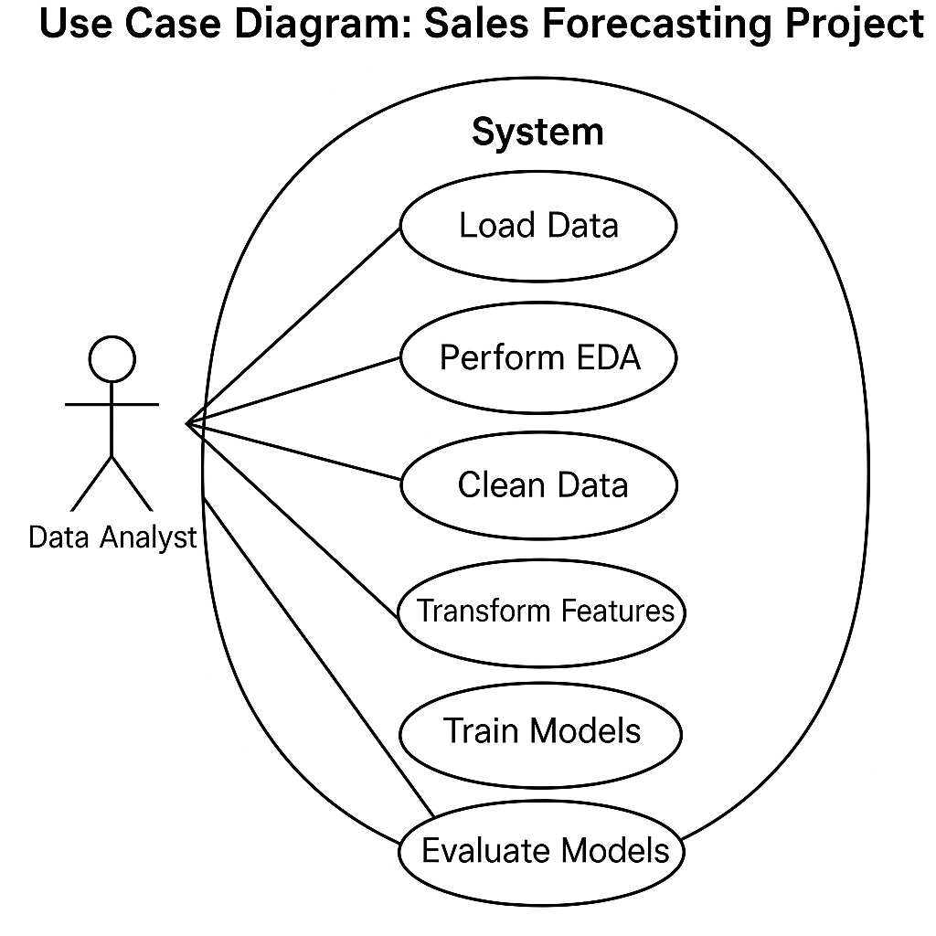

**Fig.1. Use-case diagram**

* + 1. **Use-Case Descriptions**

This section explains the major interactions between system users and the inventory forecasting system, as shown in the use-case diagram.

#### Actors:

* **Admin**
  + Responsible for uploading historical sales data, initiating the forecasting process, and managing system access.

#### Inventory Manager

* + Uses the system to view forecast results, analyze insights via the dashboard, and download reports for decision-making.

#### Use-Cases:

**Upload Data**

* **Actor(s):** Admin
* **Description:** Allows the admin to upload historical sales data in a predefined format (e.g., CSV/Excel). This is a prerequisite step for initiating the forecasting process.

#### Generate Forecast

* **Actor(s):** Admin
* **Description:** After data is uploaded, the admin can trigger the forecasting module, which processes the input and predicts future inventory demand using machine learning or statistical models.

#### View Dashboard

* **Actor(s):** Admin, Inventory Manager
* **Description:** Both admin and inventory manager can access a dynamic dashboard that displays forecast trends, inventory analytics, and actionable insights in visual form (e.g., charts, tables).

#### Download Reports

* **Actor(s):** Inventory Manager
* **Description:** Inventory managers can download detailed reports containing forecast data, insights, and recommendations. These reports help in inventory planning and procurement decisions.

### Chapter 3: Analysis & Conceptual Design & Technical Architecture

* 1. **Technical Architecture**

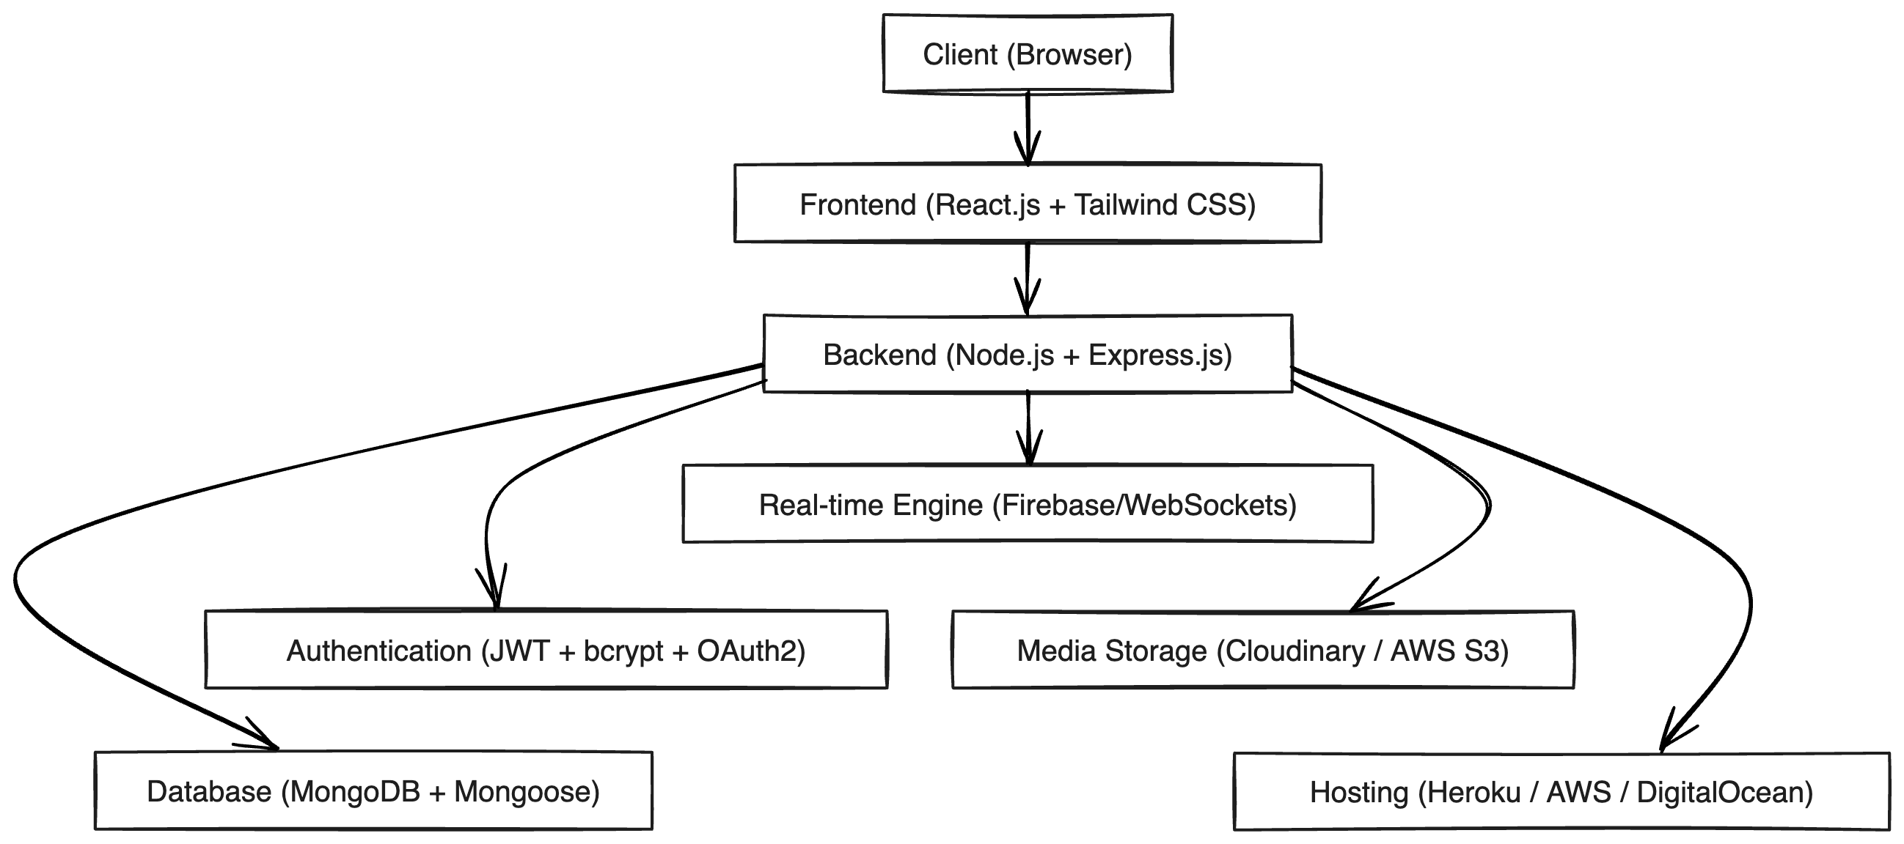

**Fig.4. Technical Architecture**

* 1. **Sequence Diagram**

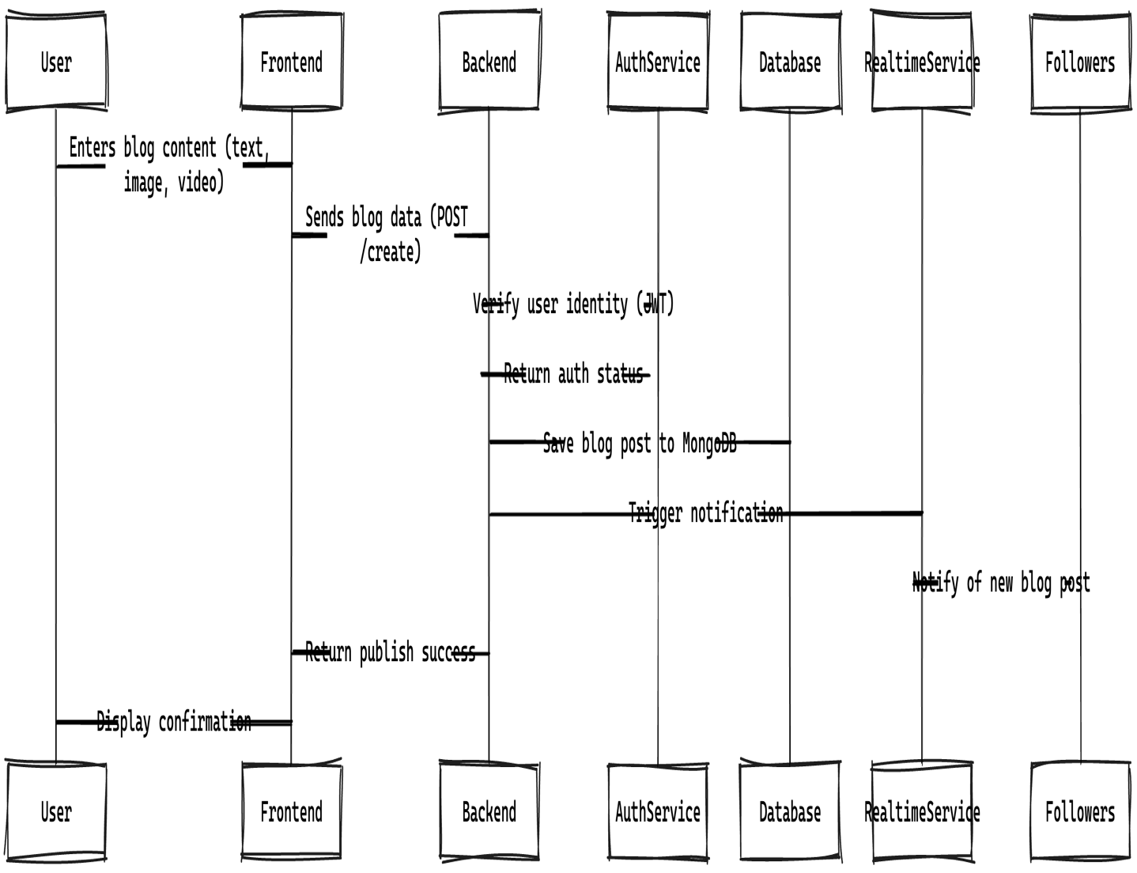**Fig.3. Sequence Diagram**

* 1. **Class Diagram**

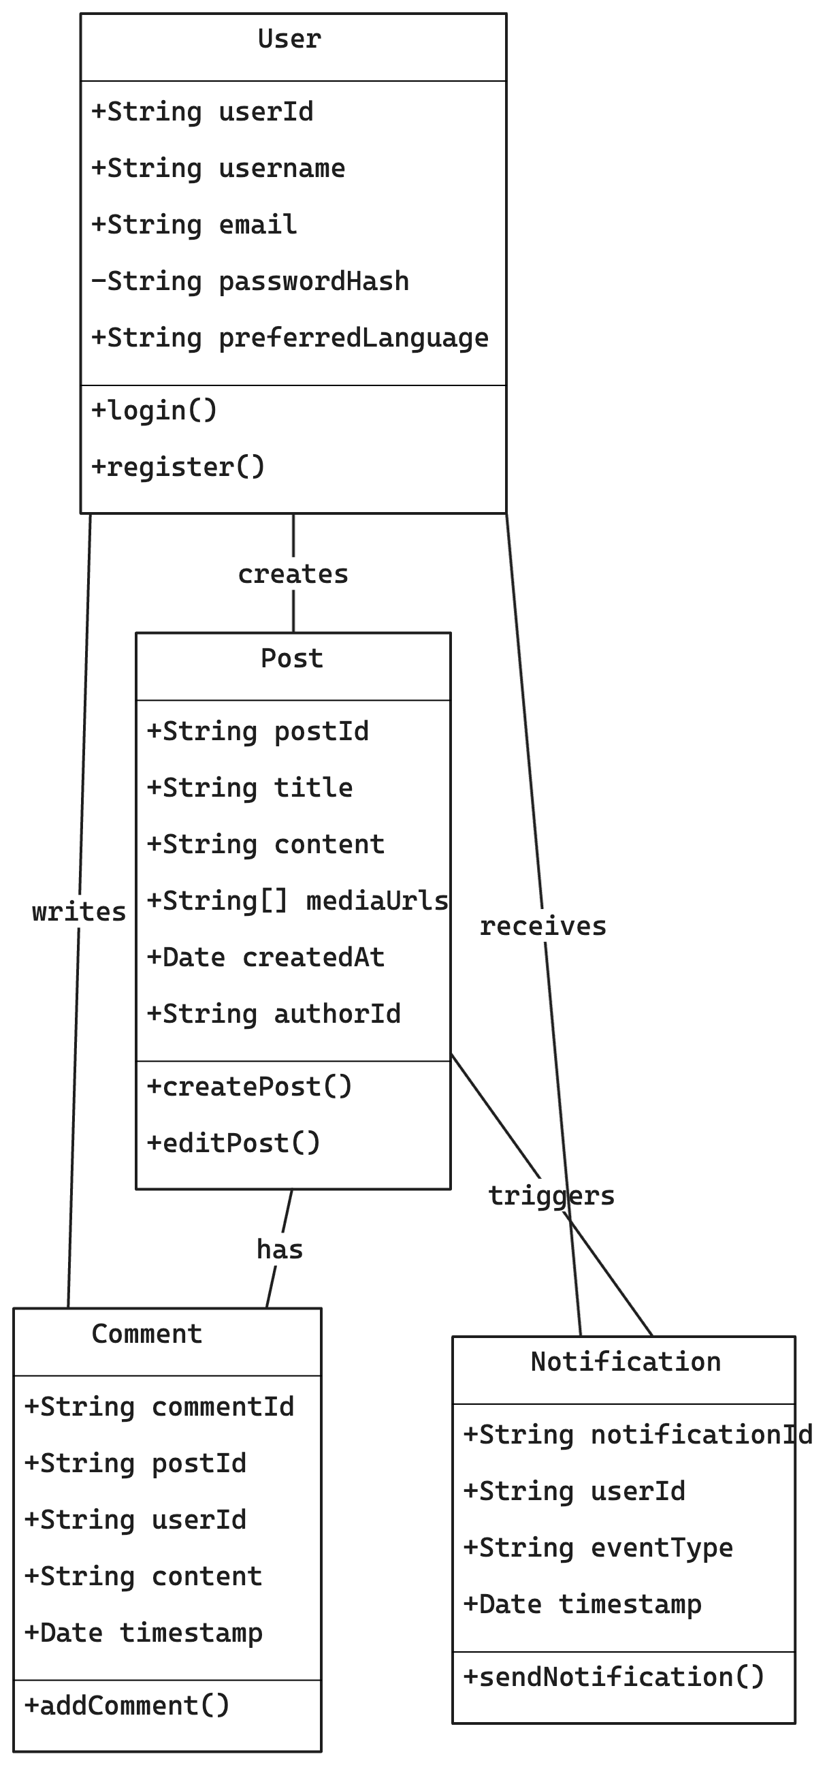

**Fig.4. Class Diagram**

* 1. **DFD**

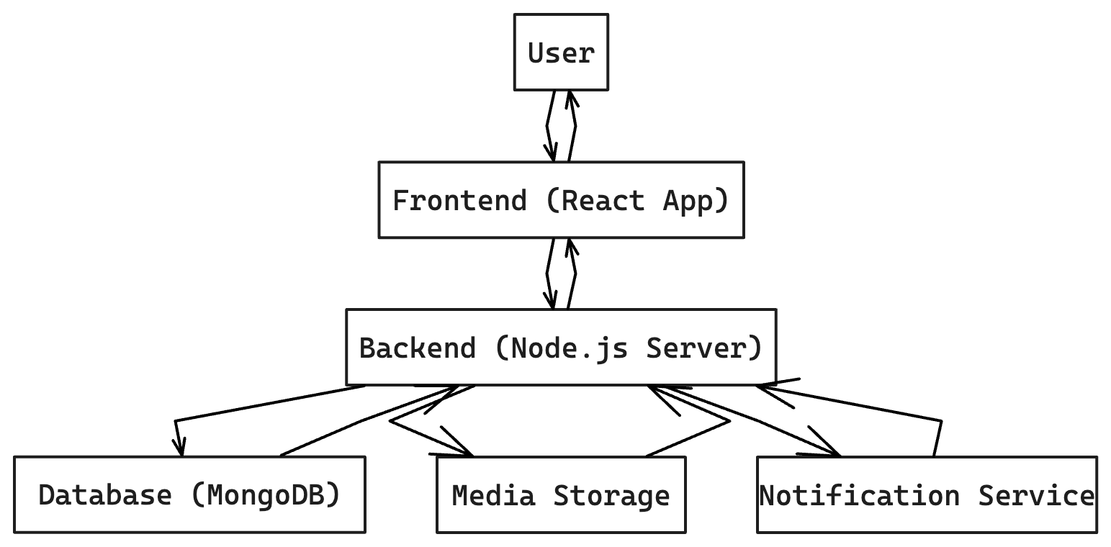**Fig.5. DFD**

* 1. **User Interface Design**

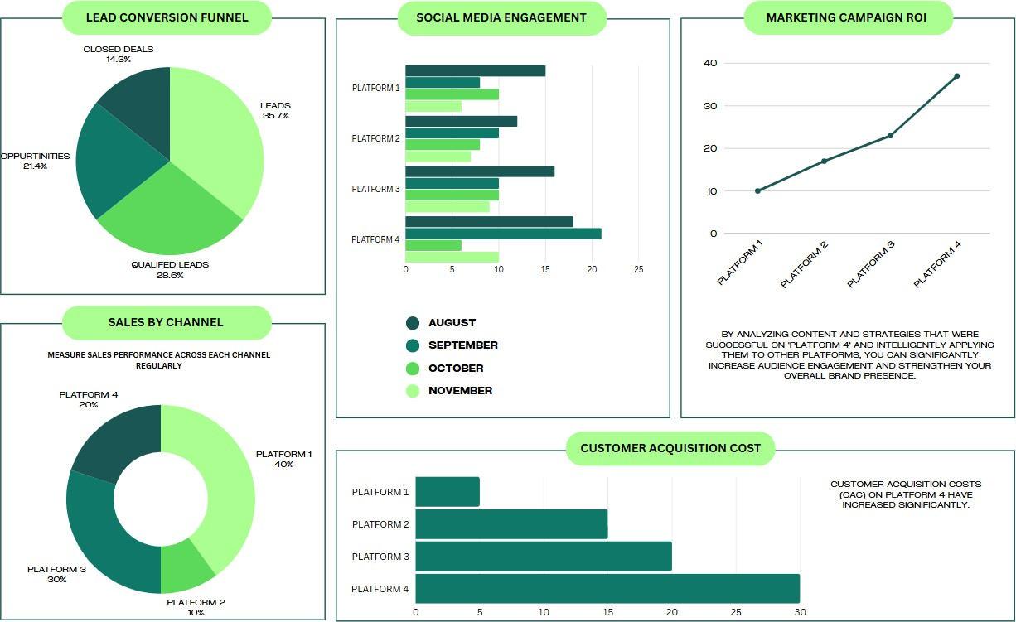

**Fig.6. User Interface**

* 1. **Data Design**
     1. **Schema Definitions**
     2. **E-R Diagram**

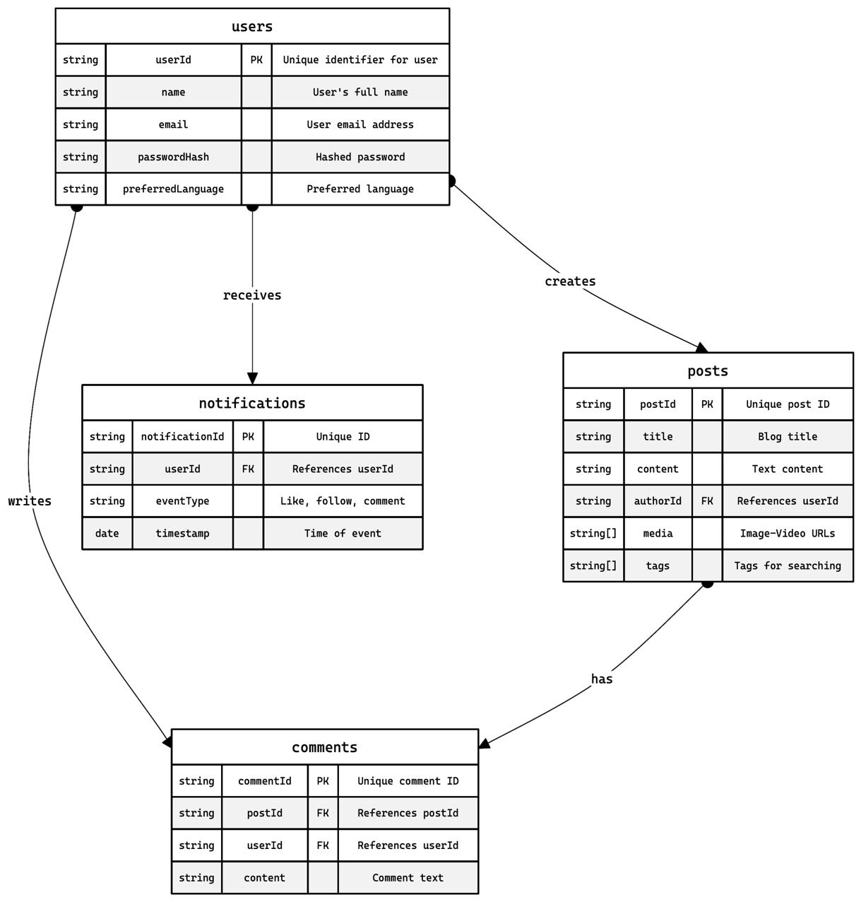

**Fig.7. ER Diagram**

### Chapter 4: Implementation & Testing

* 1. **Methodology**

The methodology outlines the structured approach used in developing the Smart Inventory Management System. It includes stages that ensure proper planning, implementation, and testing of the application.

* **Problem Identification and Requirement Gathering:** A thorough understanding of current inventory management challenges was carried out through research and stakeholder feedback to determine system requirements.
* **Feasibility Study:** Technical, economic, and operational feasibility were analyzed to ensure the project was realistic, cost-effective, and sustainable for deployment in real business environments.
* **System Design and Architecture Planning:** Based on the gathered requirements, the system's architecture was designed using modular principles, enabling scalability and maintainability. Key components like frontend, backend, and database layers were defined.
* **Data Collection and Preprocessing:** Historical sales data was collected and cleaned to handle missing or noisy values. This ensured that machine learning models could be trained on reliable inputs.
* **Model Selection and Training:** Time series forecasting techniques and supervised learning models (e.g., Linear Regression, Random Forest, or ARIMA) were implemented and evaluated based on forecasting accuracy.
* **Implementation:** The frontend was developed using HTML, CSS, and JavaScript frameworks (like React or Angular), while the backend used Python (Flask/Django) or Node.js. Database integration with MySQL or MongoDB was established.
* **Testing and Debugging:** The system underwent multiple testing phases—unit testing, integration testing, and system testing—to ensure correctness, reliability, and performance.
* **Deployment:** The application was deployed on cloud hosting platforms such as AWS or Heroku for real-time usage and accessibility.
* **User Training and Feedback:** Users were introduced to the system with basic training

and walkthroughs. Feedback was collected to identify potential improvements and future.

* + 1. **Proposed Algorithm**

To forecast future product demand using historical sales data, we propose the use of a **Time Series Forecasting Algorithm**, with an emphasis on machine learning techniques that balance accuracy and interpretability. The following steps outline the general workflow of the proposed forecasting algorithm:

#### Step-by-Step Algorithm Description:

**Data Collection**

* + - * Historical sales data is collected from user uploads in CSV/Excel format.
      * Data includes fields like product ID, quantity sold, date, location, etc.

#### Data Preprocessing

* + - * Handle missing values and outliers.
      * Convert date columns to proper datetime format.
      * Group data by product and date to generate daily/weekly sales trends.
      * Normalize or scale data if required for ML models.

#### Feature Engineering

* + - * Extract relevant features such as:
      * Day, week, month, season
      * Lag features (previous sales values)
      * Moving averages (e.g., 7-day, 30-day)
      * Promotional events or holidays (if applicable)

#### Model Selection

Depending on dataset size and business needs, one of the following is used:

* + - * **ARIMA (AutoRegressive Integrated Moving Average)** for simple time-series analysis.
      * **Facebook Prophet** for trend/seasonality-aware forecasts.
      * **LSTM (Long Short-Term Memory)** networks for deep learning-based forecasting.
      * **Random Forest Regressor** or **XGBoost** for machine learning regression-based predictions.

#### Model Training

* + - * Split the data into training and testing sets.
      * Fit the model using the training data.
      * Optimize hyperparameters using grid search or cross-validation if applicable.

#### Demand Forecast Generation

* + - * Predict future product demand for the specified time period (e.g., next week/month).
      * Forecasts are generated for each product individually.

#### Post-Processing

* + - * Convert predicted values to readable formats.
      * Aggregate forecasts if needed (e.g., per category or location).
      * Generate summary statistics like confidence intervals.

#### Output Display

* + - * Show forecast results on the dashboard using visual tools (charts, graphs).
      * Provide downloadable reports for further analysis.
  1. **Implementation Approach**

The implementation of the Smart Inventory Management System follows a modular, scalable, and data-driven approach. The goal is to build a functional web-based system that enables users to upload historical sales data, process it using predictive algorithms, and access meaningful forecasts through an intuitive interface.

#### Front-End Development

**Technologies Used:** HTML5, CSS3, JavaScript with a front-end framework such as React.js or Vue.js.

#### Features:

* User-friendly dashboard for viewing forecasts.
* Data upload interface for CSV/Excel files.
* Visualization components (charts, graphs) for interpreting forecast results.
* Role-based access for Admin and Inventory Manager.

#### Back-End Development

**Technologies Used:** Python (Flask/Django) or Node.js.

#### Responsibilities:

* Handle data processing requests from the front end.
* Manage user roles and authentication.
* Route data between the front end, ML model, and database.

#### Forecasting Module

**Implementation Tools:** Python libraries like Pandas, NumPy, Scikit-learn, Statsmodels, Prophet, or TensorFlow/Keras (for LSTM).

#### Process:

* Read uploaded historical data.
* Clean, preprocess, and structure the data.
* Generate predictions using time series or machine learning models.
* Output forecast results for front-end visualization and report generation.

#### Database Integration

**Database Used:** MySQL or MongoDB.

#### Purpose:

* Store uploaded sales data.
* Store forecast results and report files.
* Manage user details and role-based access.

#### Deployment

**Hosting Platform:** AWS, Heroku, or other cloud platforms.

#### Features:

* Scalable server configuration.
* Secure access via login.
* Continuous deployment and maintenance.

#### Testing and Validation Approach:

* Unit testing for individual modules (upload, forecast, reports).
* Integration testing for full workflow validation.
* Accuracy testing of forecasting algorithm using real and sample data.
  + 1. **Introduction to Languages, IDEs, Tools, and Technologies**

To implement a robust and scalable Smart Inventory Management System with predictive modeling capabilities, a combination of modern programming languages, frameworks, IDEs, and tools has been used. These technologies were selected for their performance, community support, scalability, and suitability for web-based applications and machine learning tasks.

#### Programming Languages

**Python**

* Used for backend development and implementing the forecasting algorithms.
* Rich ecosystem of libraries such as Pandas, NumPy, Scikit-learn, and Prophet.

#### JavaScript

* + Core scripting language for front-end interactions.
  + Enables dynamic content updates and asynchronous communication with the server.

#### HTML5 & CSS3

* + Used for structuring and styling the front-end UI.
  + Provides responsive and accessible design across devices.

#### Frameworks and Libraries Flask / Django (Python)

* Lightweight and efficient frameworks for building REST APIs and handling server-side logic.

#### React.js / Vue.js (JavaScript)

* Front-end libraries/frameworks for building interactive user interfaces and dashboards.

#### Pandas, NumPy, Scikit-learn

* Used for data manipulation, preprocessing, and classical machine learning.

#### Facebook Prophet / ARIMA / LSTM

* Forecasting libraries used for time series prediction models.

#### Database Technologies MySQL / MongoDB

* MySQL for relational data storage and structured queries.
* MongoDB for flexible and scalable document-based storage (optional).

#### IDEs and Code Editors Visual Studio Code (VS Code)

* Primary IDE used for both front-end and back-end development.
* Supports extensions for Python, JavaScript, Git, and Docker.

#### Jupyter Notebook

* Used for developing and testing forecasting algorithms interactively.

#### Deployment & Hosting Heroku / AWS / Render

* Cloud platforms used for deploying the web application.
* Supports scalability, uptime monitoring, and easy integration with GitHub.

#### Version Control Git & GitHub

* Used for version control, team collaboration, and repository management.
  1. **Testing Approaches**
     1. **Unit Testing**

1. **Test Cases**

|  |  |  |  |  |
| --- | --- | --- | --- | --- |
| **Test Case ID** | **Module** | **Test Description** | **Expected Result** | **Status** |
| TC-01 | Data Upload | Verify CSV/Excel file upload with correct format | Data accepted and stored in database |  |
| TC-02 | Data Upload | Upload file with missing columns | Error message shown; file rejected |  |
| TC-03 | Forecasting Algorithm | Predict demand for next 7 days | Forecast array with 7 values returned |  |
| TC-04 | Forecasting Algorithm | Run forecast on empty dataset | Graceful failure with warning or null output |  |
| TC-05 | API – Get Forecast | Retrieve forecast for a given product ID | JSON response with forecast values |  |
| TC-06 | Dashboard Display | Check rendering of graphs with data | Graphs show correct labels and values |  |
| TC-07 | User Login | Login with valid credentials | User is redirected to dashboard |  |
| TC-08 | User Login | Login with invalid password | Error message displayed |  |

* + 1. **Integration Testing**

1. **Test Cases**

|  |  |  |  |  |
| --- | --- | --- | --- | --- |
| **Test Case ID** | **Integration Module** | **Test Description** | **Expected Result** | **Status** |
| IT-01 | Upload → Backend  → Database | Upload CSV and store in database | Data appears in the database correctly |  |
| IT-02 | Upload → Forecast Engine | Upload triggers forecast generation automatically | Forecast results generated successfully |  |
| IT-03 | Forecast → Dashboard View | Display forecast data on graphs after processing | Graphs show correct future demand per product |  |
| IT-04 | Login → Role- Based Access | Admin vs. Manager access to different features | Restricted areas hidden from unauthorized roles |  |
| IT-05 | Database → Report Generator | Generate downloadable report from forecast results | Correct and complete report file is generated |  |
| IT-06 | API → Dashboard (Real-Time) | Fetch live forecast data via API and update dashboard | Dashboard updates dynamically with new data |  |
| IT-07 | User Session → Multiple Views | Ensure session consistency while navigating different UI modules | User remains authenticated across all system views |  |

## CHAPTER 5: RESULTS AND DISCUSSIONS

**5.1 User Interface Representation**

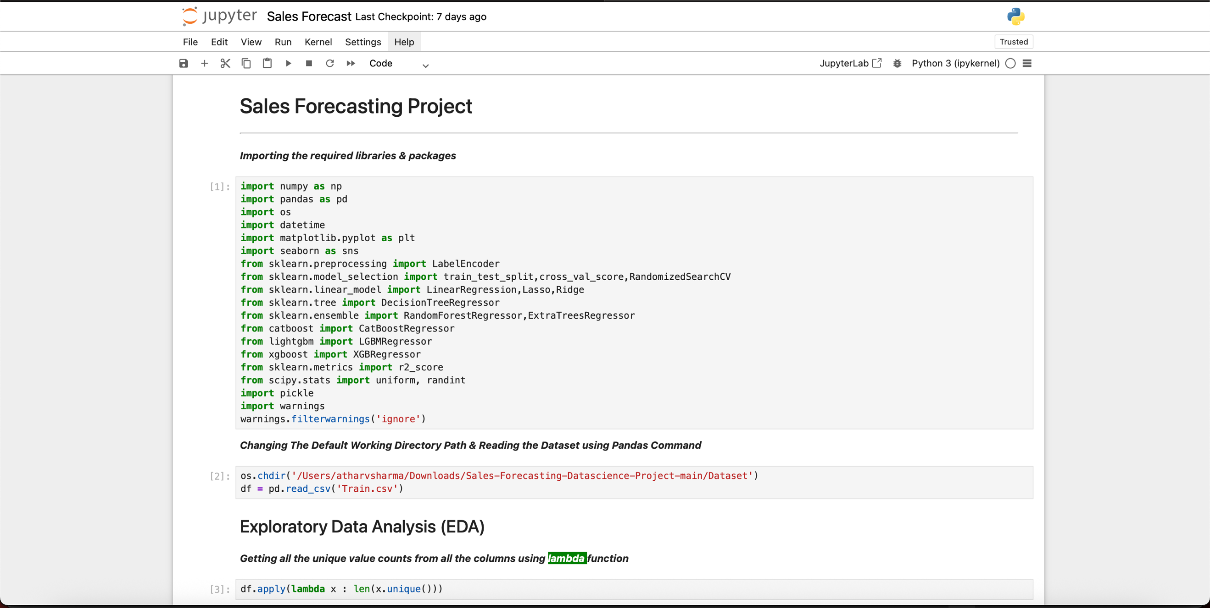

**5.1.1 Brief Description of Various Modules**

|  |  |  |
| --- | --- | --- |
| **Module** | **Brief Description** | **Related Visuals** |
| Data Ingestion | Load and preprocess supermarket_sales.csv | (No diagram needed) |
| EDA Module | Analyze trends by gender, branch, payment method, etc. | Count of Item_Type, Outlet_Type, Item_Fat_Content |
| Modeling (if any) | Predict total income or branch performance (optional) | Correlation Heatmap |
| Visualization Module | Generate insights through count plots and distributions | All uploaded plots |

**5.2 Snapshot of System with Brief Description**

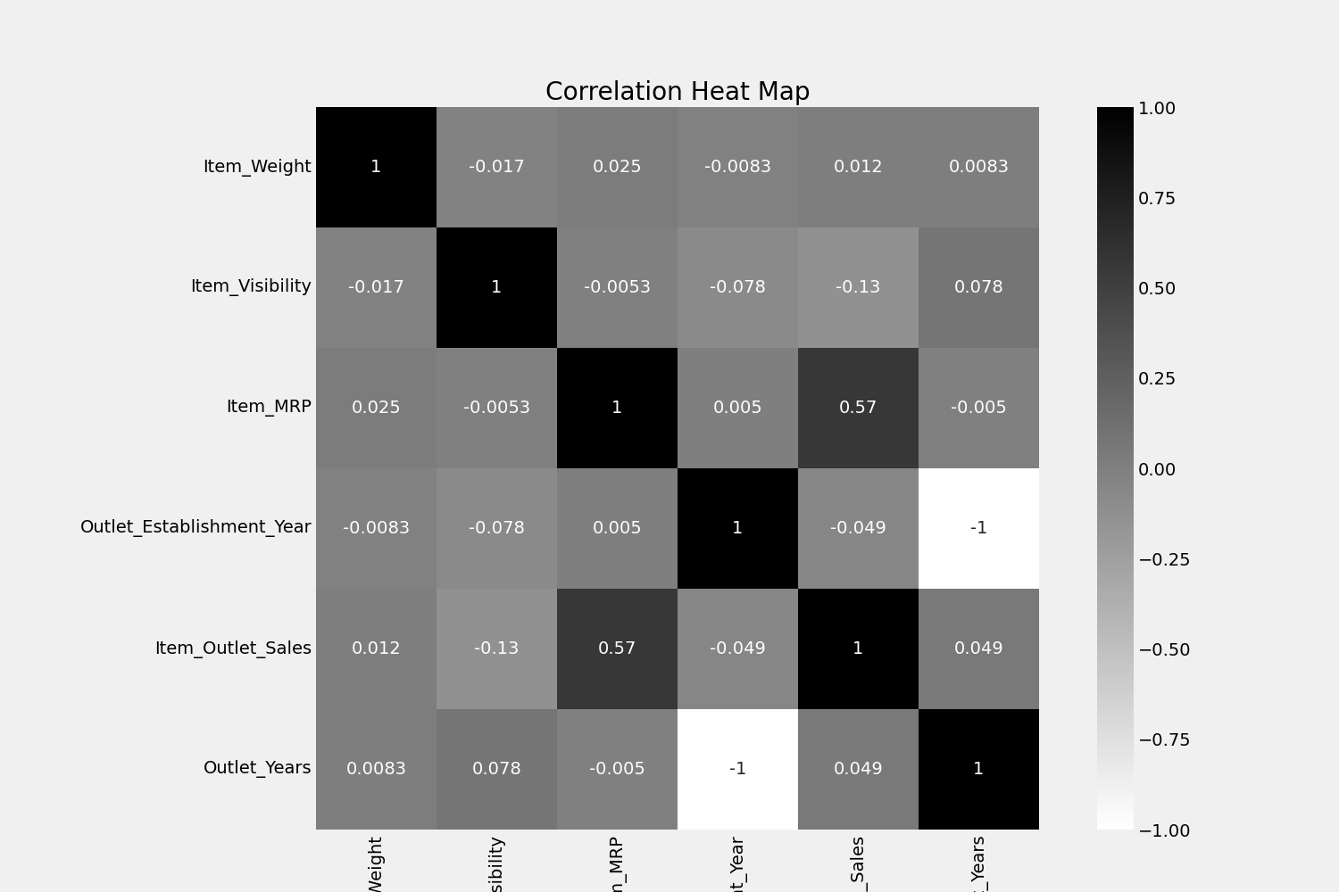

Fig 5.2 Correlation Heat Map

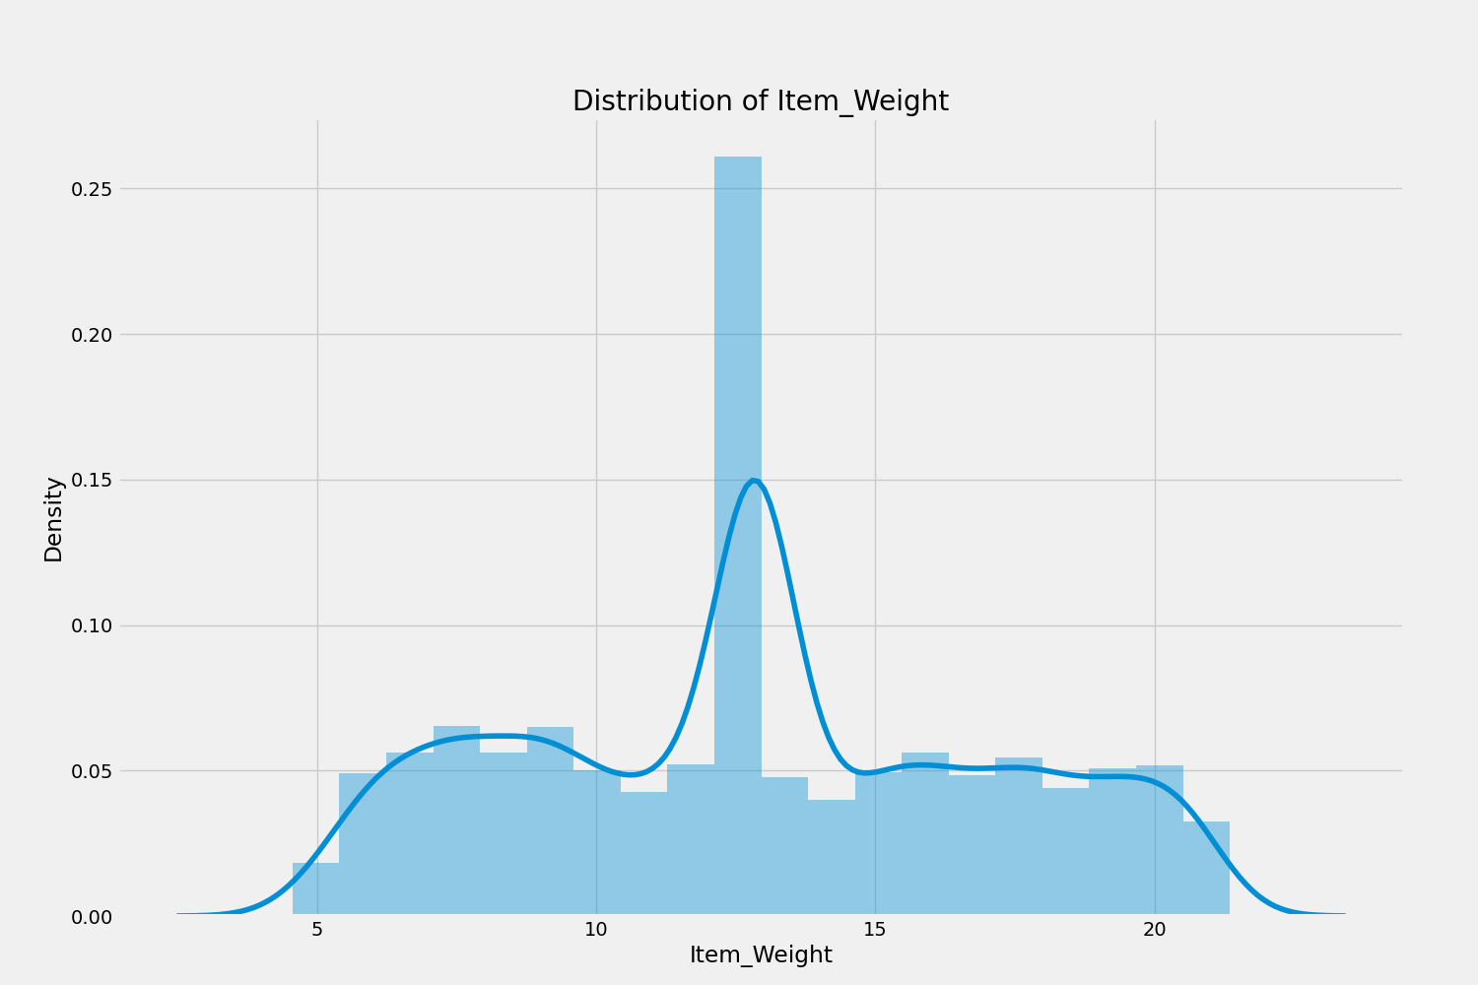

Fig 5.2 Distribution of Item Weight

* 1. **Database Description**

Exploratory Data Analysis (EDA)

* Overview of sales by city, branch, product line, etc.
* Analyze customer types, payment methods, or gender distribution.
* Time-based analysis: sales by day, month, hour.
* Find out top-performing product lines and peak sales hours.

Visualizations

* Bar charts or pie charts for product line sales.
* Heatmap of total sales across cities and branches.
* Time series of daily or monthly revenue.

Predictive Analytics

* Forecast total sales for next month using regression or time series models.
* Classify high-value vs low-value customers.
* Analyze factors affecting customer ratings.

Data Cleaning

* Handle missing or inconsistent values (e.g., time formats, price errors).
* Convert date/time to usable formats.
* Ensure all columns are of the correct data type.

**5.3.1 Snapshot of Database Tables with Brief Description**

## 

## Table 5.3.1 Database Description

**CHAPTER 6: CONCLUSION AND FUTURE SCOPE**

* 1. **Conclusion**

The project successfully demonstrated the development of a Smart Inventory Management System that leverages historical sales data to forecast future product demands using predictive modeling techniques. By addressing the limitations of existing inventory systems—such as poor forecasting, lack of real-time data, and scalability issues—this system offers a cost-effective and intelligent alternative for modern businesses.

Through the integration of machine learning models, real-time inventory tracking, and a user- friendly interface, the system ensures optimized stock levels, reduces the risks of stockouts and overstocking, and supports data-driven decision-making. The use of time series analysis and regression-based forecasting methods provided reliable predictions that align closely with historical patterns and seasonal trends.

The modular architecture of the system allows for scalability and adaptability, making it suitable for retail, e-commerce, manufacturing, and other inventory-dependent sectors. The project also ensured ease of deployment through the use of cloud platforms and open-source technologies.

Overall, this project contributes to the ongoing digital transformation of supply chain and inventory operations, proving that data-centric approaches can significantly improve business efficiency and customer satisfaction.

* 1. **Future Scope**

While the current system provides accurate demand forecasting and efficient inventory management, several enhancements can be made to increase its functionality, scalability, and commercial applicability. The future scope of this project includes:

#### Integration with Live POS Systems

* + - Connect the system with Point-of-Sale (POS) software to enable real-time updates of sales data and inventory levels.

#### Mobile Application Development

* + - Develop a mobile version of the system for on-the-go access by inventory managers and staff.

#### Advanced Forecasting Techniques

* + - Incorporate deep learning models such as LSTM (Long Short-Term Memory) networks for more complex time series forecasting, especially for highly volatile demand data.

#### Automated Reordering System

* + - Implement an automated reordering mechanism that places supplier orders based on forecasted stock requirements and predefined thresholds.

#### Multi-Language and Multi-Currency Support

* + - Extend the system to support different languages and currencies for broader geographical use.

#### User Behavior Analytics

* + - Integrate customer behavior analysis to correlate inventory demand with customer preferences, marketing campaigns, and seasonal trends.

#### Integration with Supplier and Warehouse Systems

* + - Enable seamless communication between the inventory system and external supplier or logistics platforms to streamline procurement and distribution.

#### AI-Based Anomaly Detection

* + - Use AI to detect unusual trends or demand spikes, which may be indicative of market changes or potential fraud.

#### Dashboard Personalization and Notifications

* + - Add customizable dashboards and real-time alerts or recommendations for inventory actions.